**PROCUREMENT AND TENDER MANAGEMENT SYSTEM**

Done by SANGWA Emmanuel

Email: [sangwa22@gmail.com](mailto:sangwa22@gmail.com)

Tel: 0784113888

**Contents**

**1.** **DIAGRAMS** 3

**a.** **ERD** 3

**b.** **USER INTERFACE MENU** 4

**c.** **USER ROLES** 5

**2.** **DEFAULT DATA** 5

**a.** **USERS** 5

**i.** **ADMIN** 5

**ii.** **PROCUREMENT OFFICER** 5

**iii.** **USER (STAFF)** 5

**iv.** **VENDOR** 5

**3.** **CRITERIA GROUPS AND CRITERIA** 5

**a.** **Qualifications and Experience** 5

**b.** **Technical Expertise:** 5

**c.** **Financial Stability:** 6

**d.** **Compliance with Regulations:** 6

**e.** **Quality Assurance:** 6

**f.** **Health and Safety:** 6

g. **Environmental Considerations**: 6

**h.** **Cost and Pricing** 6

**i.** **Project Plan and Timeline** 6

**j.** **References and Past Performance:** 6

**k.** **Capacity and Resources:** 7

**l.** **Communication and Reporting** 7

**m.** **Conflict of Interest:** 7

**n.** **Innovation and Value-Added Services:** 7

**o.** **Scalability:** 7

**TECHNONOLGIES USED** 8

**TOOLS USED** 8

# **DIAGRAMS**

## **ERD**

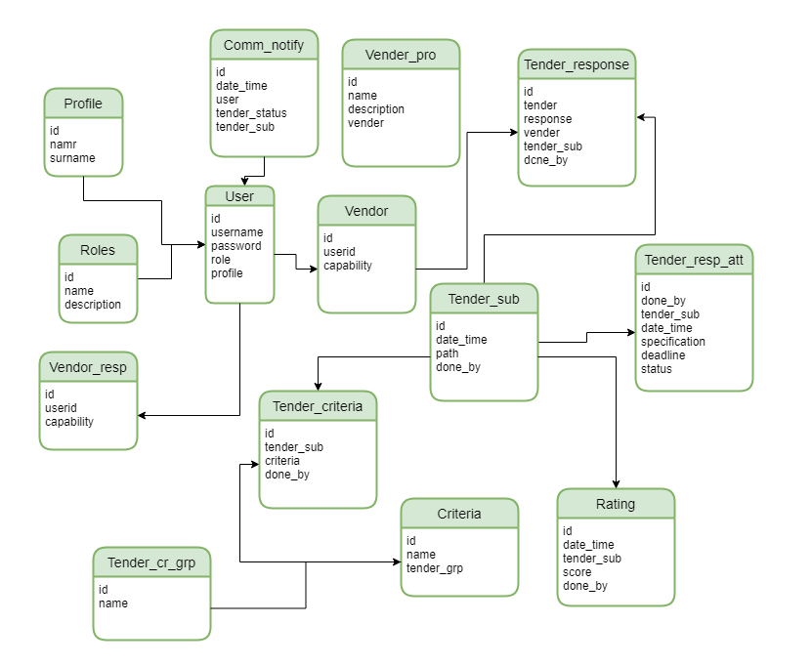

## **USER INTERFACE MENU**

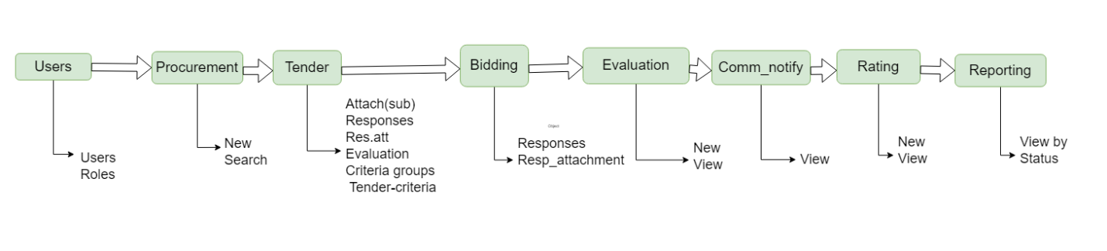

## **USER ROLES**

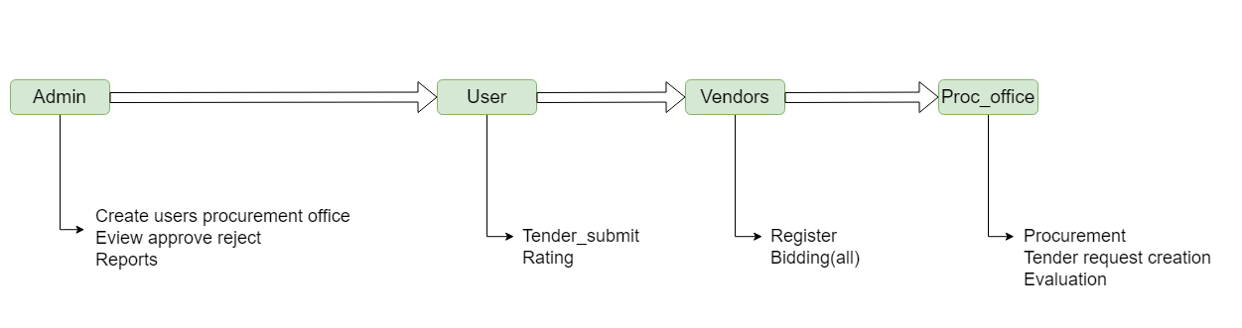

# **DEFAULT DATA**

## **USERS**

### **ADMIN**

* The admin user has admin as username and password (1,2,3).

### **PROCUREMENT OFFICER**

* Procurement offer user has proc_offecer as username and password(1,2,3).

### **USER (STAFF)**

* The User has user as username and password (1,2,3).

### **VENDOR**

* The Vender has vender as username and password (1,2,3).

# **CRITERIA GROUPS AND CRITERIA**

## **Qualifications and Experience**

* Provide details of previous similar projects and references.
* Specify the required professional certifications or licenses.
* Evaluate the bidder's track record and years of experience in the industry.

## **Technical Expertise:**

* Assess the bidder's technical capabilities to perform the work.
* Check if they have the necessary equipment, technology, and infrastructure.
* Evaluate their ability to meet specific technical requirements of the project.

## **Financial Stability:**

* Request financial statements or credit references to assess their financial stability.
* Verify if they can handle the project's financial demands.
* Ensure they have appropriate insurance coverage.

## **Compliance with Regulations:**

* Ensure bidders comply with all relevant laws, regulations, and standards.
* Check if they have a history of legal or regulatory violations.

## **Quality Assurance:**

* Inquire about their quality control processes and certifications.
* Evaluate their commitment to delivering high-quality work.

## **Health and Safety:**

* Assess their safety policies and track record in promoting a safe work environment.
* Verify compliance with health and safety regulations.

## **Environmental Considerations**:

* Evaluate their environmental policies and commitment to sustainability.
* Check for any past environmental violations.

## **Cost and Pricing**

* Compare their proposed costs and pricing structure.
* Ensure they provide a detailed breakdown of costs.
* Assess if the pricing is competitive and within budget.

## **Project Plan and Timeline**

* Evaluate their proposed project plan, timeline, and milestones.
* Assess if they can meet project deadlines.
* Ensure alignment with your project schedule.

## **References and Past Performance:**

* Contact references provided by the bidder to verify their performance on previous projects.
* Consider their reputation and feedback from past clients.

## **Capacity and Resources:**

* Determine if they have the necessary workforce and resources to handle the project's scope.
* Evaluate their subcontractor relationships, if applicable.

## **Communication and Reporting**

* Assess their communication skills and responsiveness.
* Evaluate their reporting and documentation processes.

## **Conflict of Interest:**

* Confirm that there are no conflicts of interest that could compromise the project.

## **Innovation and Value-Added Services:**

* Encourage bidders to propose innovative solutions or value-added services.
* Evaluate their ability to bring added value to the project.

## **Scalability:**

* Assess their ability to scale up or down based on project requirements.

# **TECHNONOLGIES USED**

The system is designed using the below technology

* SPRING BOOT 2.7
* MAVEN BUILDING TOOL 3
* JAVA 11
* MARIADB

# **TOOLS USED**

* NETBEANS
* DBEAVER
* VS CODE